# Style Guide

* H1 should be in all caps and sans serif, everything else should be sentence-text and serif font
* Colors to be used:
  + Background: #C5A8E0 
  + Text color: #8805E0 
  + Links: #4E2CDE 
  + Visited links: #7684DE 
  + Hover links: #2CB4DE 
* Photo captions will be italic
* All headings should be centered

# Page sketches

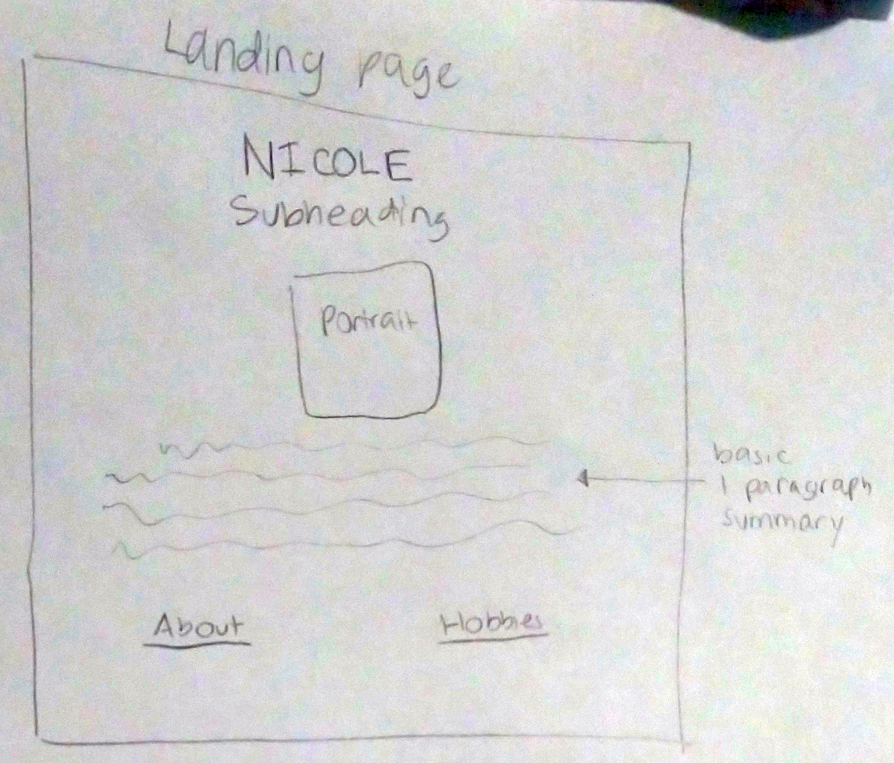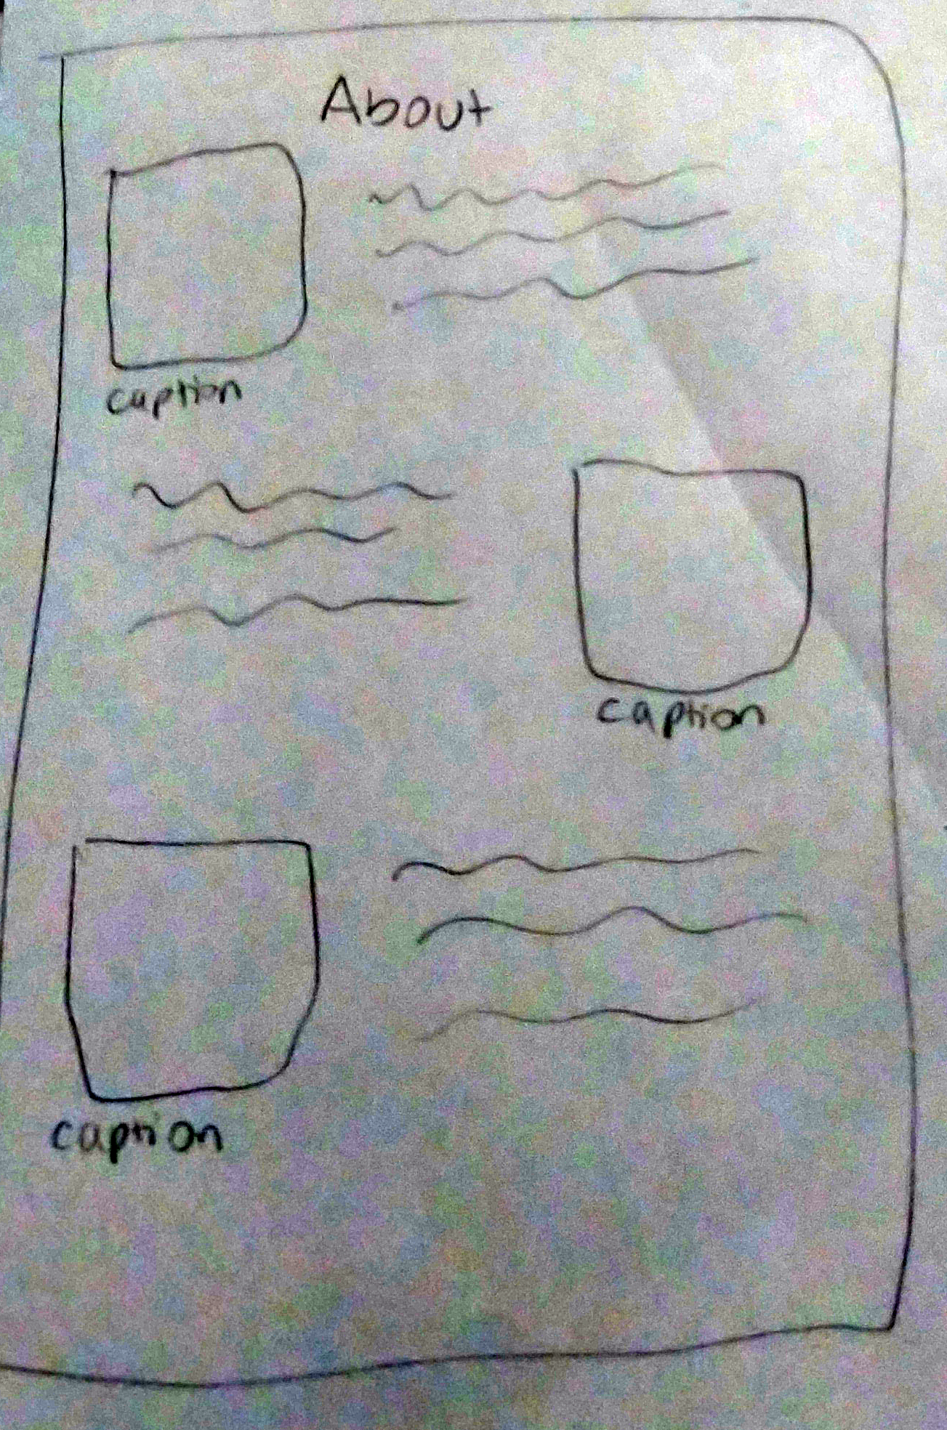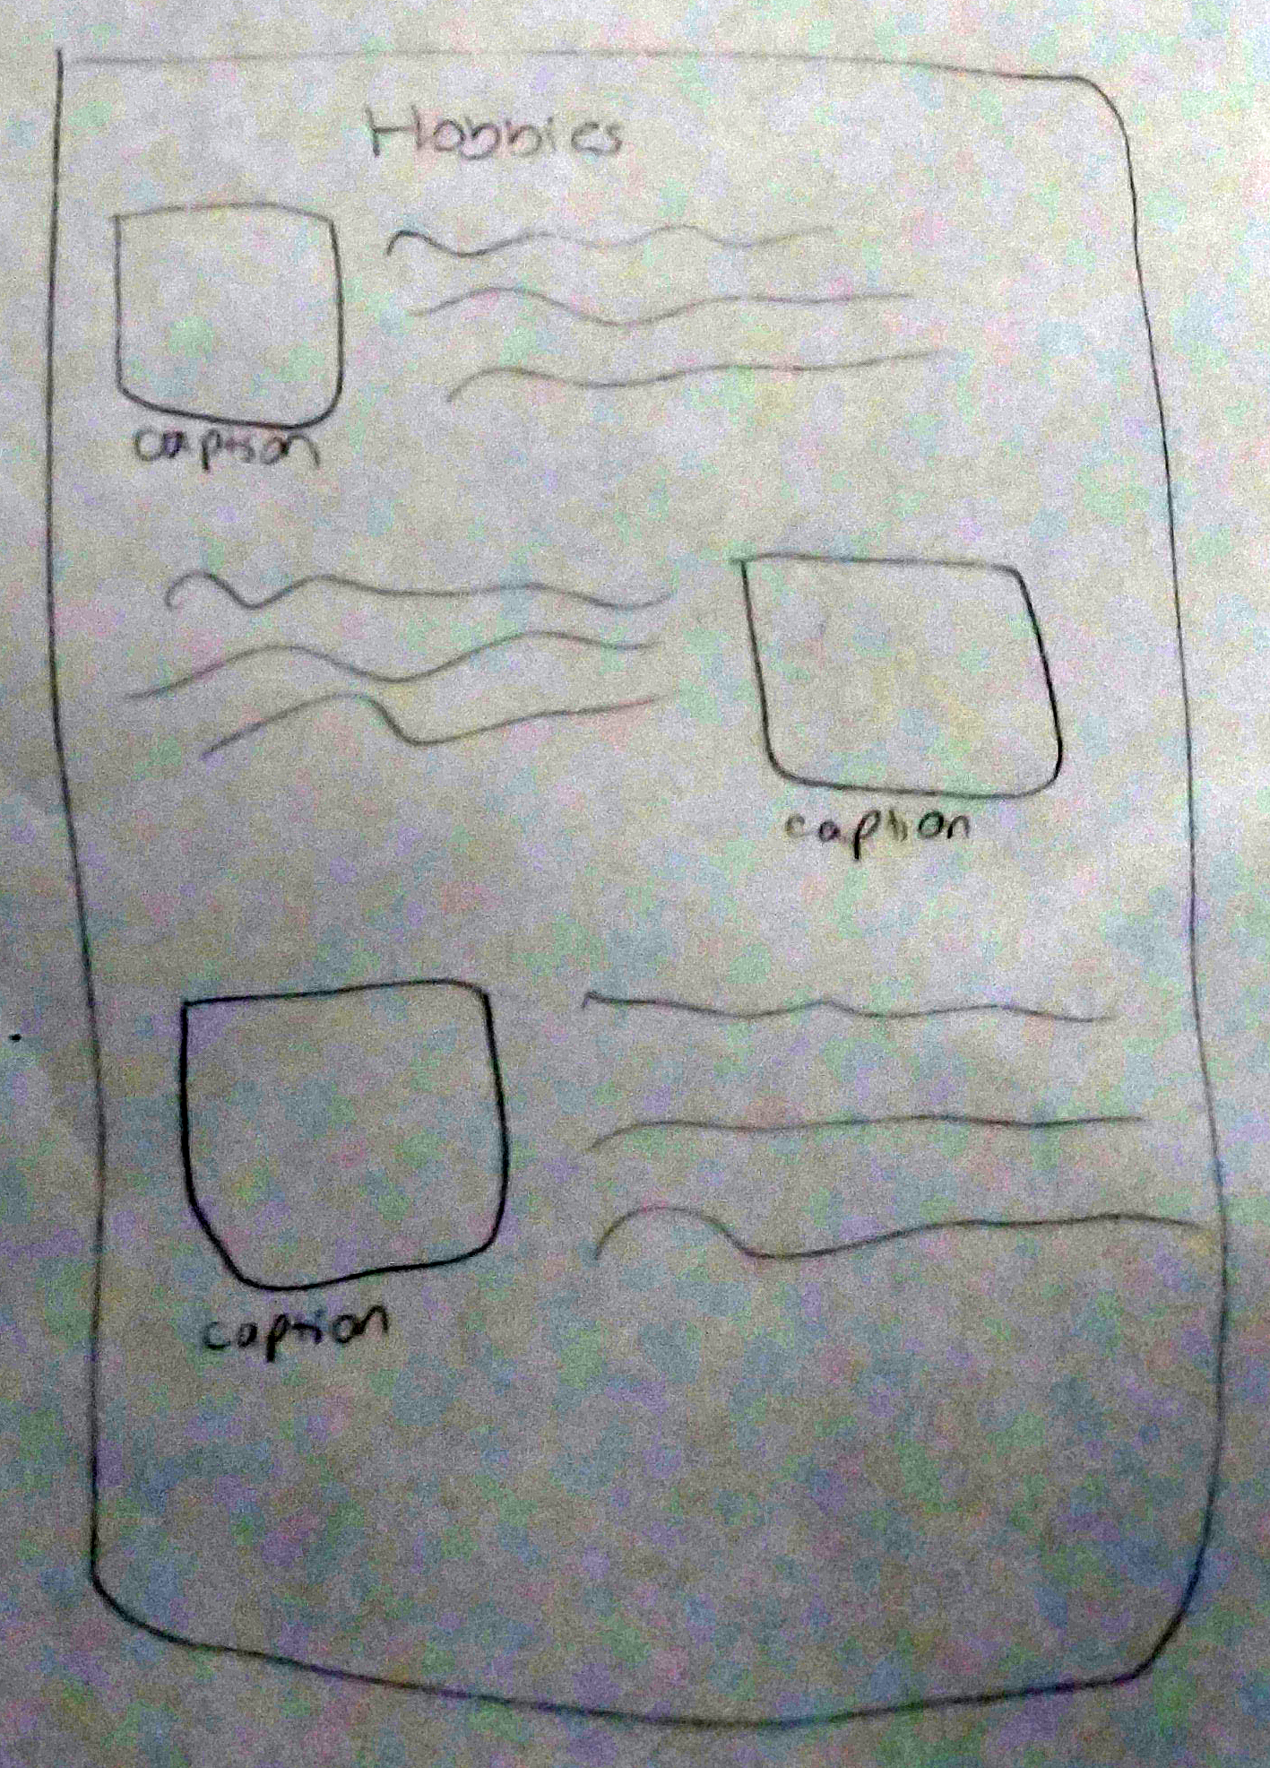

# Interview

1. **What are the most important goals you have achieved in the past?**

There are a lot of important goals I have already achieved. I graduated from college and achieved many different professional credentials. I have created a successful professional career with a good income. I married my college sweetheart and together we bought our dream home in the mountains. I have a rich social life and there’s nothing more I could ask for. I feel very grateful.

1. **What is your most important goal for the future?**

My most important goal for the future is to start a family. Other than getting married and buying a home, that’s one thing I’ve always wanted in order to have a full life. But since I recently got pregnant with my first child, it looks like I’m already on the way to that! I can’t wait to meet my new little son or daughter in just a few short months.

1. **You have trained for and worked in many different fields. Why do you think that is?**

Yeah, at 30 I’ve already been a preschool teacher, trained as a yoga instructor and interior designer, worked as a professional photographer, and now I’m a professional writer. I’m sure I’m missing some too. I think I’ve just always believed that a job should make you come alive and just feel right. I’m also the kind of person who has a huge number of interests and hobbies, and I am willing to put in the work to pursue different things and apply for many jobs until I find the right one. So as soon as I know that my current job is not inspiring me, I figure out what *would* inspire me and how I could pursue that instead.

1. **Do you feel more settled now, as a professional writer?**

That’s a good question, and I don’t think I can guarantee that. I’m not sure if I’m even the type of person to do one job for decades at a time. I still haven’t worked as a yoga instructor or interior designer despite my training, for one thing. And I am very interested in the film and screenwriting industry, so that’s something else I would consider pursuing.

1. **What did you want to be as a kid?**

Wow, honestly, I’m not sure if I even remember. I think I wanted to be a teacher. And of course, that was something I started to concentrate on in high school, and I worked with preschool-aged children for years. But in the end, I don’t think that was my true passion. Or at least it wasn’t something I wanted to dedicate the rest of my life to.

1. **What are your favorite hobbies to do in your spare time?**

I like to travel and explore new places, even right in my own backyard. Yoga, of course, is a huge passion of mine. I pretty much like to do anything active or creative: hiking, kayaking, swimming, dancing, arts and crafts, playing music.

1. **Are there any new hobbies you’d like to try in the future?**

Of course, I think I want to try everything at least once, but I’d have to think on it. One thing that sounds boring, but I’ve never learned and would really like to, is knitting or crocheting. Either one, or both.

1. **What was the happiest time of your life so far?**

Honestly, I’ve been pretty fortunate and had a pretty happy life, other than the normal challenges and losses that everyone experiences. My childhood was wonderful. I didn’t grow up rich or anything, but we were always having fun family gatherings, going on fun road trips, or exploring somewhere new. My favorite time always was and still is Christmastime. It feels like people become nicer and happier, and it just feels like a magical time. Still, I like to think the best is yet to come now that I’m starting my own family. Now we get to make our own memories and choose our own adventures.

1. **What’s on your bucket list?**

I’d really like to go to Italy. I’m half-Italian and I’ve always wanted to see the land of my ancestors, especially after learning some of their stories. We planned to go for our honeymoon, but we eventually decided to stay in the US for financial reasons. Hopefully we can afford it in the not too distant future, with a couple of little ones in tow!

1. **If someone was writing your biography, what’s one thing you would want to make sure they included or got across?**

I have done a lot of different things in my life, and to some people it makes it seem like I don’t have a coherent story and I just run around doing whatever I want. But to me, there is a coherent story. I always say that my mission is to understand, connect, and create more good. I feel like that has been the running theme throughout my life and everything I have tried and accomplished.

# Biography

Ever since my sister Nicole was little, connecting with people was very important to her. She shined most at family gatherings, where she had a knack for being a social butterfly and the center of attention. She was a happy kid, full of life and always up for an adventure. She drew people to her and it was very easy for her to make friends.

It’s really true that people’s personalities don’t change that much over time. As an adult, she is much the same as she was before. She’s always organizing events to bring people together and show them how to have fun. She’s happily married with plenty of friends, and will now be starting her own family soon. She loves to pursue active and creative hobbies, just like the active games and arts and crafts she loved as a kid. Depending on the day, you might find her hiking in the local mountains, kayaking in the local river, or painting pictures with her husband, who is also very artistic.

In terms of what she does and has done for work, a better question would almost be what she *hasn’t* done. She started out teaching preschool, then moved onto photography. She then trained in quick succession as a yoga instructor, interior designer, and a copywriter, the latter of which she currently does professionally.

But don’t expect her to stay still. In the future, she might still want to make use of her other credentials or even look for work as a screenwriter. Seeing as she has excelled at everything she’s done so far, I wouldn’t bet against her.